Social Media Post:

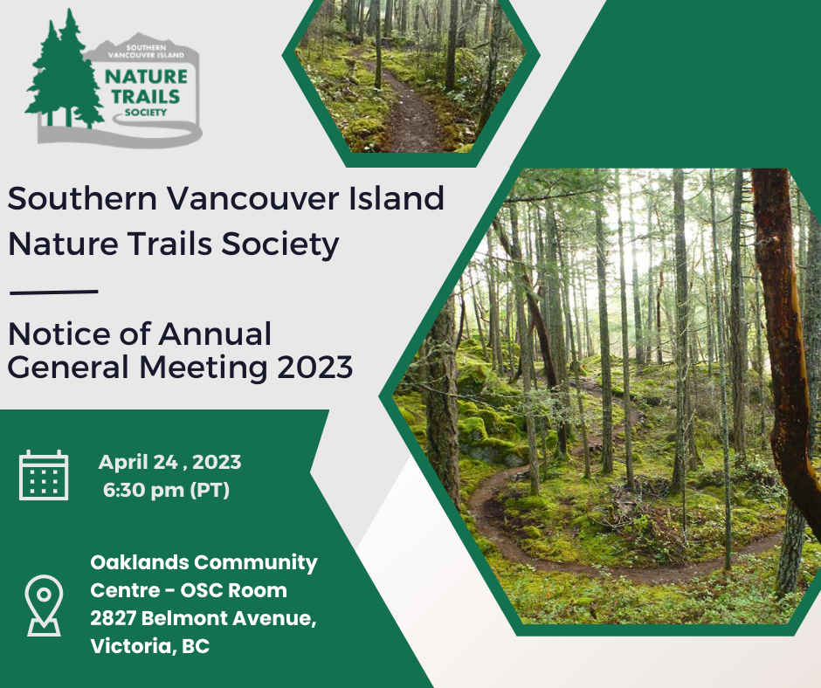

We are pleased to invite you to the 2023 Southern Vancouver Island Nature Trails Society Annual General Meeting on Monday, April 24 at 6:30 pm at the Oaklands Community Centre OSC Room.

Join us for speakers, refreshments, and prizes as we provide an update on our accomplishments in 2022 and exciting plans for the coming year!

Please email us at naturetrailssociety@gmail.com to confirm your spot. We look forward to seeing you soon!

For more details on the Annual General Meeting or to become a member, visit our website https://naturetrailssociety.com/

Website Post

https://www.canva.com/design/DAFfZAfpi30/B8lsTEp3-FMWGw_vD9CNeQ/view?utm_content=DAFfZAfpi30&utm_campaign=share_your_design&utm_medium=link&utm_source=shareyourdesignpanel

